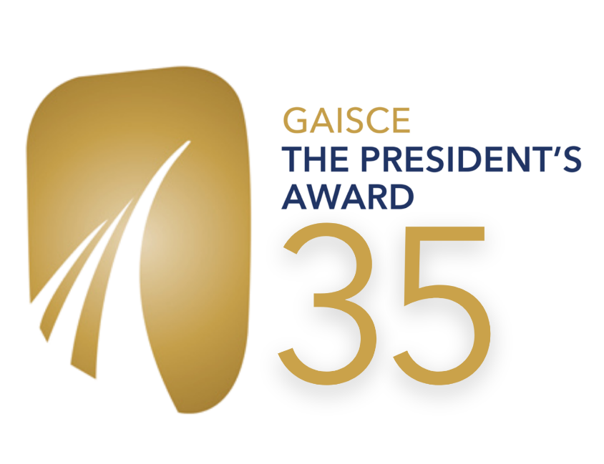
GAISCE - THE PRESIDENT'S AWARD
Role Application Form

Position: Development Officer part-time (Maternity Cover)

Please complete application in type or use black pen for scanning purposes. Please fill in all sections.

The following application will cover the following:

- Personal Details
- Employment/Professional experience
- Education and Training
- Your post-second level education and educational achievements
- Relevant external or internal courses, training, or professional development
- Voluntary experience
- Overall profile and suitability for the post
- Why you are applying
- How your skills and experience meet the job description criteria (see recruitment pack)
- Qualities you will bring to the role
- An example of an activity you have organised
- Your references
Section 1: Your personal details

First name:
Surname:
Address for correspondence:
Email address:
Telephone Number:
Are there any restrictions to your working in Ireland?
If successful, when could you take up the post?
Do you have a full, clean driving licence?
Do you own or have access to a car?
Where/from who/what platform did you first hear about this position?

SECTION 2: Employment/Professional Experience

Please give details of all work experience relevant to the role being applied for, beginning with your present or most recent employer:

Dates employed (month and year) | Employer’s name and address | Job title, whom you were reporting to & description of duties/responsibilities | Reason for leaving | Current Salary
(add more lines to the above table if required)
SECTION 3: Education and Training

Please provide details of your post-second level education and educational achievements, indicating if you did not pass or complete a course:

Name of establishment / awarding body (Please start with most recent) | Dates attended (to/from)  (State full or part time) | Qualification / accreditation achieved
(add more lines to the above table if required)

Please give details of any relevant external or internal courses, training, or professional development that you have undertaken (including dates and length or course, accreditation etc.):

Name of body (Please start with most recent) | Dates (to/from) | Detail
(add more lines to the above table if required)

If you are a member of any professional body or associations, please provide details here:
Name of professional body or association | Date membership granted | Status of membership

Please give details of any volunteering experience relevant to the role being applied for, beginning with your present or most recent volunteer role:

Dates (month and year) | Organisation name and address | Role title & description of duties/responsibilities | Reason for leaving
(add more lines to the above table if required)

SECTION 4: Overall profile and suitability for the post

Please outline why you are applying for the role:
(300 words max)

The Job Description (in the recruitment pack) for the role of Development Officer part-time with Gaisce - The President's Award outlines the skills, experience and personal attributes required to successfully carry out the responsibilities of the post.

Please outline how your skills and experience meet the criteria: (1000 words max)
Add paragraph space to this box if you need additional space.

Please outline the qualities you would bring to the post: (300 words max)

Please tell us about a time you developed a new professional opportunity, outlining the objectives, your role, and the process you followed. Please provide an example relevant to the development work required for this role.
(400 words max)

Finally, what is something outside of your work that you are passionate about? (300 words max)

SECTION 5: References

Please give the name, address, telephone number and occupation of two referees who would be in a position to assess your skills, knowledge, and aptitude for this post. At least one should be your current or most recent employer.
Referees must not be related to you.

Name: | Name:
Position: | Position:
Address:  Email: | Address:  Email:
Telephone: | Telephone:
(Please note we will not contact referees until we have informed you in advance)

Please provide below details of any access arrangements we can make to ensure you can successfully engage with the interview.

Candidates called to interview may be asked to provide documentary evidence to support the information provided in this application form.

DECLARATION

I declare that the information provided in this application form is, to the best of my knowledge, true and complete.

Applicant Signature:

Date:

- Please send your completed and signed application form by email (digital signature) with the subject line ‘Development Officer PT Application’ to recruitment@gaisce.ie
- Please ensure to save this application document with your name included before you send it to us
- We do not accept CVs or cover letters
- Strict closing date for receipt of applications (email) is 12 noon Monday May 16, 2022

Thank you so much for your interest in this role.

