Gold Award Requirements

Gold Award* | Challenge Areas |  |  |  |  |  | Dependent on Gaisce history
 | Personal Skill | Community Involvement | Physical Recreation | Adventure Journey | Residential Project | Portfolio | +
 | 52 weeks | 52 weeks | 52 weeks | 3 days  4 nights | 5 days  4 nights | Required | + 26 weeks in one area  (required only if participant does not have Silver Award)
*Participants must be between 17 – 25 years of age when registering. Registration fee of €25.

A participant who already has a Silver Award when they begin their Gold Award completes at least 1 hour a week for 52 weeks in the areas of Personal Skill, Community Involvement and Physical Recreation. If a participant does not have a Silver Award before they begin their Gold Award, they will be required to do an additional 26 weeks of activities in one area. An Adventure Journey, a Residential Project and a Portfolio are also part of the award.

Number of hours per week
Participants do at least one hour per week in each of the 3 ongoing areas. They can choose to manage activities in a way that suits them; there is no time limit so they can take more than 52 weeks to complete the award. The 52 weeks do not have to be consecutive (e.g. participants can do activities every 2nd week or they can take a break for a few weeks and resume activities when it suits them).

Doing a Gold Award means committing to 52 weeks of activities; if participants do more than one hour a week in any of the areas, those additional hours cannot be counted – it’s a commitment to 52 weeks of activities rather than a specific number of hours. Gaisce expects participants to do at least one hour a week in each area, but recognise the number of weeks rather than the number of hours.

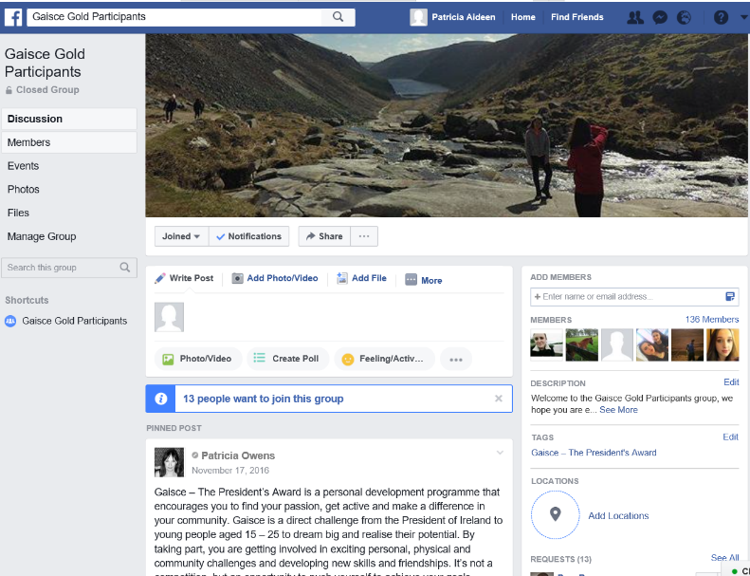
Support for Gold Participants
Gold Participants who are over 18 years of age are invited to join the ‘Gaisce Gold Participants’ Facebook page. This page allows people to communicate with each other, share opportunities and organise Adventure Journeys.

Activities
Participants will discuss their chosen activities with their PALs before they begin their award. They will work together to ensure that chosen activities are appropriate, they are sufficiently challenging, they demonstrate progression in a specific area and helps them to develop their skills, knowledge and abilities while also being realistic and achievable. Each activity chosen must last for a minimum of 52 weeks – participants commit to focusing on one activity in each area and develop their skills in that area. For anybody in full or part time education, activities must be extra-curricular.

Participants should look at www.gaisce.ie to view our Challenge Partners. They are organisation that Gaisce recognise because they offer opportunities to participants that helps them to meet the programme requirements.

For Personal Skill activities, participants must:
- Take up a completely new activity or seek to improve their ability in an activity that they are already engaged in that can be pursued for 52 weeks with set goals and targets.
- Undertake activities in your own time.
- Show regular commitment, progress, and improvement in your chosen skill.
- Ensure that there is structure to the learning and a method of recording and monitoring it to demonstrate progress.
- There is no requirement to pay for classes.

For Community Involvement activities, participants must:
- Undertake a meaningful activity regularly where they are donating their time to that cause/charity/event/project for 52 weeks. This means that whilst some activity may take place within school, university or work hours, most of it should occur outside of these scheduled times.
- Show regular commitment (at least one hour a week)
- Engage in activities that benefit others.

For Physical Recreation activities, participants must:
- Either take up a completely new physical activity or seek to improve their ability in an activity that they are already engaged in.
- Choose an activity regularly that requires physical exertion for 52 weeks.
- Show regular commitment, progress and improvement.
- Undertake activities in their own time.

There are some examples of popular activities on our website – but it’s not an exhaustive list, so there are many more activities that are suitable.

‘I believe in myself… The harder the challenges, the more determined I am to finish them.
Gold participant

Adventure Journey
A Gold participant will spend 4 days and 3 nights on their Adventure Journey. Most people hike 80km over the 4 days, those that choose to cycle cover 300km over the 4 days. It can take place in Ireland or outside of Ireland at any time of year.
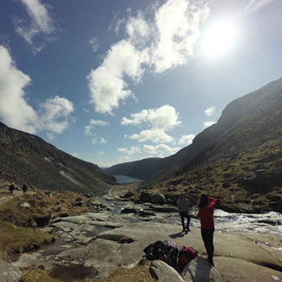
PAL supervision
If a Gold participant is under 18 years of age, their PAL must accompany them on their Adventure Journey and supervise them for the whole trip for insurance and Child Protection reasons.

If a participant is over 18, their PAL is not required to supervise their Adventure Journey. However they will communicate their Adventure Journey plans to their PAL before the trip. Health and Safety will also be a consideration and the journey should consist of between 4 and 10 people. Additional people that go on the trip do not need to be Gaisce participants.

Adventure Journey Requirements
- PALs’ Role: Participants must communicate their Adventure Journey plans with their PAL to ensure that they are meeting all of the required elements and their PAL is happy to sign off on the Adventure Journey when completed.
- Planning: The group will prepare and plan the journey themselves and make decisions.
- Journey: The hike/cycle etc. must have a starting point and an end point. So participants will travel from A-B, B-C, C-D, D-E. They cannot stay in the same place each night and start from the same place each morning. It needs to be a continuous journey with a specific starting point and a final destination – without these it cannot be considered a journey. A looped walk is not acceptable at Gold level.
- Purpose: The journey should have a specific purpose – apart from the distance covered. It might be an artistic purpose (take a series of photographs to record the natural world), historic purpose (compare land use now and how previous generations used it), environmental purpose (examining water levels, water quality etc.), team building purpose (experiencing group dynamics and social interaction, roles within groups etc.). The group’s purpose and their findings should be documented in the portfolio.
- Transport: Participants can choose to hike, cycle, canoe or sail – or travel on a horse or camel. With canoeing, sailing or horse riding, the distance covered is less significant than the amount of hours spent on the journey each day. Both parties will discuss this and a decision about what is appropriate in terms of time and distance will depend on factors such as previous experience, terrain, facilities, logistics, weather etc.
- Accommodation: Participants stay in a hostel, camp, or self-contained accommodation.
- Meals: They will cook at least one substantial meal per day (this could be breakfast, lunch or dinner).
Adventure Journey Policy: Read the Adventure Journey policy available on the Gaisce website.

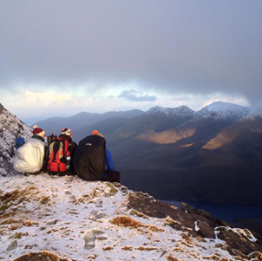

Gold participants should consider:
- Communicating with their PAL when they have finished.
- Taking photographs/videos along the way for their portfolio.

Expedition or Exploration
Participants can choose to do either an Expedition or an Exploration. An Expedition is a journey with a purpose, and involves a hike/cycle etc. An Exploration is a purpose with a journey. This option might be chosen by a participant who is unable to do a 4 day hike/cycle because of an underlying medical condition etc.
Instead of a hike, participants who choose to do an Exploration are required to spend the 4 days staying away from their usual accommodation doing a project on a specific topic that allows them to undertake independent research, meet with people who are connected to the subject area and create a report/recommendations/observations. These project based activities should take 4 days of effort.

Examples of Expeditions | Examples of Explorations
Walk a number of stages of the Wicklow Way following the guide written by J. B. Malone the founder of the Wicklow Way. | Exploring the natural world: glaciation, erosion, geology, coastal studies, river valleys, plant studies, bird studies, animal studies, insect studies etc.
Plan a hike on Achill Island following the footsteps of one of the many artists who sought inspiration for their work on the island. | Exploring historic land use.
Hike on the Burren, considering the impact of tourism on the flora, fauna of the Burren. | Investigating the evolution or extinction of a language.
Hike on the Slieve Bloom Mountains, keeping a detailed account of how as the group followed the Leave No Trace principals. | Exploring human impact on the landscape: visitor pressure in national parks, litter studies, pollution monitoring, surveys of numbers of walkers in remote areas etc.
Hike in the Comeragh Mountains using photography to record the journey. | Personal artistic expression or aesthetic appreciation.
Identify a Way Marked Way trail and research how many megalithic tombs or markings are along the chosen route, using photography or sketches to record them. | Investigating group dynamics in challenging conditions
Hike the Camino de Santiago and observe the social interaction that takes place between people. | Preparing a wheelchair users guide to Glendalough National Park including the hostel and local hotels.

‘What my youth service and Gaisce gave me was an opportunity to do something I otherwise wouldn’t have done.…
I now feel more included in my community and feel respected.’
David Murtagh, Gold Awardee

Residential Project
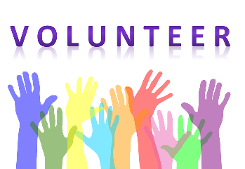
A Residential Project is a 5 day, 4 night commitment to volunteering time and effort to working as part of a team towards a specific goal, in an unfamiliar environment with people the participant does not know. It can take place in Ireland or another country at any time of the year.

Residential Project Requirements
- PALs’ Role: Participants must communicate their Residential Project plans with their PAL to ensure that they are meeting all of the required elements and their PAL is happy to sign off.
- Payment: Participants should not be paid for their residential activities, but it is acceptable to get travel and accommodation costs and subsistence covered. Getting paid and donating wages is not acceptable.
- Group: Participants must be in the company of others who are, in the majority, not their usual companions.
- Undergo briefing and/or training (if required) prior to or during the residential period so that they are able to contribute fully to the activity and derive full benefit from the experience.
- A written evaluation from a participants’ Residential Project supervisor must be included in the portfolio.
- In exceptional circumstances, the Residential Project may be spread over two separate weekends (3 days and 2 days) in the same calendar year – this would need to be communicated to PALs before undertaking.

Examples of Residential Projects
The list of possible activities is almost limitless, and some possible choices include:
- Residential Training Courses – Language courses such as the Gaelteacht
- Camps for children such as Barretstown or Sunshine House in Balbriggan
- Parish trips – e.g. supporting a community group on a trip to Lourdes etc.
- Summer School - Any skills based course that is residential
- Environment and Conservation projects – examples such as environmental clean-up projects and restoration projects. Some examples include World Wide Opportunities on Organic Farms (WOOOF), Eco Unesco etc.
- Volunteering with a charitable organisation inside/outside Ireland for a specific purpose that benefits others (e.g. teaching, sharing expertise, building/maintaining a private house or public building, etc.).

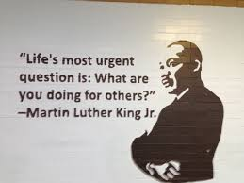

Gold Portfolio
When all elements of the Gold Award have been completed, participants create a portfolio to record the activities they completed for their Gold Award. The portfolio will contain the following details:
- Introduction: Description of participant and outline why they choose to do the award.
- Award Experience: What activities was completed for each section, what participant learned, what obstacles had to be overcome and the most memorable moments during the award.
- Conclusion: What achieving a Gold Award means, advice for other participants and any plans for the future.
- Add in photos, certificates, brochures, booklets etc.
- Include the written evaluation from the Residential Project supervisor.
- Include signed record sheets.

Participants can choose to record the information in a number of ways – there’s no set format. It could be a book, in a folder, a scrapbook, or it could be a Word document on a USB. There’s also no set length, participants can decide the length themselves. Gaisce would encourage people to include as much detail as possible though as it’s a great way to record achievements over a number of months or sometimes even years. It’s also an opportunity to acknowledge the people that supported you to complete the award, so it’s a good opportunity to highlight the support your PAL has given you and the organisations that helped you to achieve a Gold medal.
When it is completed, participants will meet with their PAL, go thought their portfolio and ensure the record sheets and all elements have been completed. When PAL has approved the portfolio, participants will send it to Gaisce (Gaisce, Ratra House, North Road, Phoenix Park, Dublin 8). PALs will approve the participant on the online system. Gaisce staff will review each portfolio and then participants will be completed on the system.

There is a limit to the number of people that can attend a Gold Award Ceremony so attendees are invited based on the date Gaisce received their portfolio. So if somebody is determined to get their award in a particular year, the earlier in that year they get the portfolio in to Gaisce, the greater their chances of being invited that December will be.

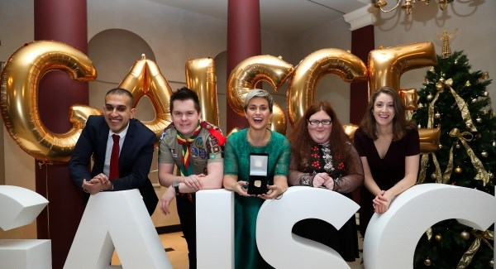
Awards Ceremony
There is one Gold Award ceremony each year and it usually takes place in Dublin each December. It is a formal event where 50/60 participants receive their Gold medal, pin and cert from the President of Ireland.

