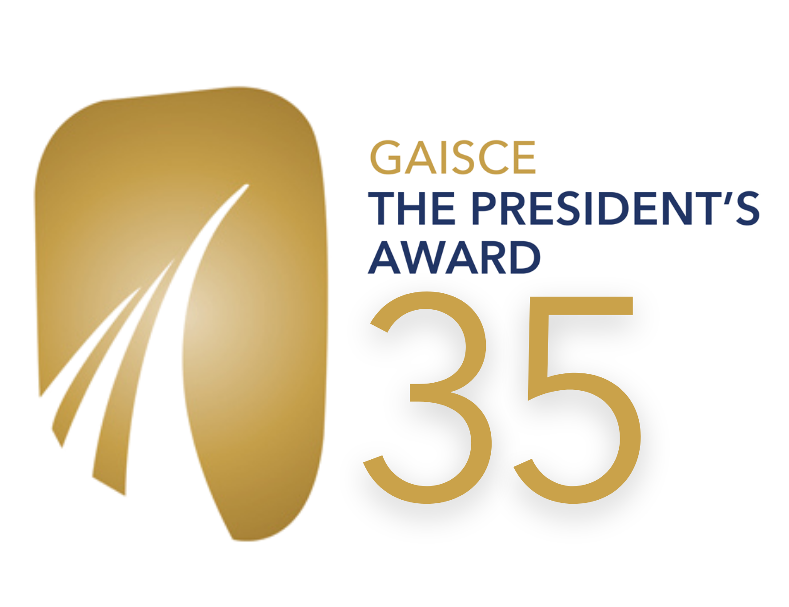
GAISCE - THE PRESIDENT'S AWARD
Role Application Form

Position: Digital Media and Communications Officer
Reporting to: Public Affairs and Communications Manager
Contract: Permanent, full-time, with a 6-month probationary period.
Salary: €34,091, DOE.
Primary Location: Ratra House, Phoenix Park, Dublin 8. Remote/from home working in line with Covid-19 health and safety in line with Government guidelines.

Please complete application in type or use black pen for scanning purposes. Please fill in all sections.

The following application will cover the following:

- Personal Details
- Employment/Professional experience
- Education and Training
  - Your post-second level education and educational achievements
  - Relevant external or internal courses, training, or professional development
  - Voluntary experience
- Overall profile and suitability for the post
  - Why you’re applying
  - How your skills meet the job specification
  - Qualities you’ll bring to the role
  - An example of a time you used social/digital media
- Your references

Section 1: Your personal details

First name:
Surname:
Address for correspondence:
Email address:
Telephone Number:
Are there any restrictions to your working in Ireland?
If successful, when could you take up the post?
Where/from who/what platform did you first hear about this position?

SECTION 2: Employment/Professional Experience

Please give details of all work experience relevant to the role being applied for, beginning with your present or most recent employer:

Dates employed (month and year) | Employer’s name and address | Job title, whom you were reporting to & description of duties/responsibilities | Reason for leaving | Salary
(add more lines to the above table if required)

SECTION 3: Education and Training

Please provide details of your post-second level education and educational achievements, indicating if you did not pass or complete a course:

Name of establishment / awarding body (Please start with most recent) | Dates attended (to/from)  (State full or part time) | Qualification / accreditation achieved
(add more lines to the above table if required)

Please give details of any relevant external or internal courses, training, or professional development that you have undertaken (including dates and length or course, accreditation etc.):

Name of body (Please start with most recent) | Dates (to/from) | Detail
(add more lines to the above table if required)

Please give details of any volunteering experience relevant to the role being applied for, beginning with your present or most recent volunteer role:

Dates (month and year) | Organisation name and address | Role title & description of duties/responsibilities | Reason for leaving
(add more lines to the above table if required)

SECTION 4: Overall profile and suitability for the post

Please outline why you are applying for the role of Digital Media and Communications Officer with Gaisce - The President's Award:
(300 words)

The Job Specification for the role of Digital Media and Communications officer with Gaisce - The President's Award outlines the skills, experience and personal attributes required to successfully carry out the responsibilities of the post.

Please outline how your skills and experience meet the criteria: (1000 words, max)

Please outline the qualities you would bring to the post: (300 words)

Please tell us about a time you used social and/or digital media to achieve a goal or bolster the efforts of a project.
How did it go, and what was the outcome? (300 words)

Candidates called to interview may be asked to provide documentary evidence to support the information provided in this application form.

SECTION 5: References

Please give the name, address, telephone number and occupation of two referees who would be in a position to assess your skills, knowledge and aptitude for this post. At least one should be your current or most recent recent employer.
Referees must not be related to you.

Name: | Name:
Position: | Position:
Address:  Email: | Address:  Email:
Telephone: | Telephone:
(Please note we will not contact referees without your prior permission)

Please provide below details of any access arrangements we can make to ensure you can successfully engage with the interview.

DECLARATION I declare that the information provided in this application form is, to the best of my knowledge, true and complete.

Signature:

Date:

- Please send your completed and signed application form by email (digital signature) with the subject line ‘Digital and Comms officer’ to recruitment@gaisce.ie.
- Please ensure to save this application document with your name included before you send it to us.
- We are not accepting CVs or cover letters.
- Strict closing date for receipt of application is midnight on Sunday, 21st March 2021, with a view to first round interviews taking place on Monday 29th, Tuesday 30th, and Wednesday 31st of March.

Thank you, and best of luck!

