Silver Award Requirements
Silver Award* | Challenge Areas |  |  |  | Dependent on Gaisce history
 | Personal Skill | Community Involvement | Physical Recreation | Adventure Journey | +
 | 26 weeks | 26 weeks | 26 weeks | 3 days, 2 nights | + 26 weeks in one challenge area  (required only if participant does not have Bronze Award)
*Participants must be between 16 – 25 years of age when registering. Registration fee of €20 required.

Silver participants complete 26 weeks of activities in the areas of Personal Skill, Community Involvement and Physical Recreation. An Adventure Journey of 3 days and 2 nights is also part of the award.

Number of hours per week
Participants do at least one hour per week in each of the 3 challenge areas. They can choose to manage activities in a way that suits them; there is no time limit so they can take more than 26 weeks to complete the award. The 26 weeks do not have to be consecutive (e.g. participants can do activities every 2nd week or they can take a break for a few weeks and resume activities when it suits them).

Doing a Silver Award means committing to 26 weeks of activities; if participants do more than one hour a week in any of the areas, those additional hours cannot be counted – it’s a commitment to 26 weeks of activities rather than a specific number of hours. Gaisce expects participants to do at least one hour a week in each area, but recognise the number of weeks rather than the number of hours.

Activities
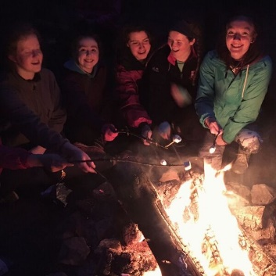
Participants will discuss their chosen activities with their PALs before they begin their award. They will work together to ensure that chosen activities are appropriate, they are sufficiently challenging, they demonstrate progression in a specific area and will help them to develop their skills, knowledge and abilities. The activities chosen will be realistic and achievable. Each activity chosen must last for a minimum of 26 weeks – participants commit to focusing on one activity in each area and develop their skills in that area. For anybody in full or part time education, activities must be extra-curricular.

Participants should look at www.gaisce.ie to view our Challenge Partners. These are organisation that Gaisce recognises because they offer
opportunities for participants that helps them to meet the programme requirements.

For Personal Skill activities, participants must:
- Take up a completely new activity or seek to improve their ability in an activity that they are already engaged in that can be pursued for 26 weeks with set goals and targets.
- Undertake activities in their own time.
- Show regular commitment, progress, and improvement in their chosen skill.
- Ensure that there is structure to the learning and a method of recording and monitoring it to demonstrate progress.
- There is no requirement to pay for classes.

For Community Involvement activities, participants must:
- Undertake a meaningful activity regularly where they are donating their time to that cause/charity/event/project for 26 weeks. This means that whilst some activity may take place within school, university or work hours, most of it should occur outside of these scheduled times.
- Show regular commitment, progress and improvement in their chosen activity (at least one hour a week).
- Engage in activities that benefit others.

For Physical Recreation activities, participants must:
- Either take up a completely new physical activity or seek to improve their ability in an activity that they are already engaged in.
- Choose an activity that requires physical exertion for 26 weeks.
- Show regular commitment, progress and improvement.
- Undertake activities in their own time.

There are some examples of popular activities on our website - but it’s not an exhaustive list, so there are many more activities that are suitable.

Adventure Journey
A Silver participant will spend 3 days and 2 nights on their Adventure Journey. Most people hike 50km over the 3 days, those that choose to cycle cover 190km over the 3 days. It can take place in Ireland or outside of Ireland at any time of year.

PAL supervision
Silver participants under 18 years of age must be accompanied and supervised by their PAL on their Adventure Journey for insurance and Child Protection reasons.
If a participant is over 18, their PAL does not have to supervise the Adventure Journey. However participants will communicate their Adventure Journey plans to their PAL before the trip. Health and Safety will also be a consideration and the journey should consist of between 4 and 10 people. Additional people that go on the trip do not need to be Gaisce participants.

Adventure Journey Requirements
- PALs’ Role: Participants must communicate their Adventure Journey plans with their PAL to ensure that they are meeting all of the required elements and their PAL is happy to sign off on the Adventure Journey when completed.
- Planning: The group will prepare and plan the journey themselves and make decisions.
- Journey: The days on the Adventure Journey must be consecutive and must involve going directly from point to point. To ensure it’s a journey, there must be a specific starting point and a final end destination. Participants travel from A – B, B – C, C – D and must spend the entire specified period of time exclusively on the Adventure Journey. A looped walk is not acceptable at Silver level.

- Purpose: The journey should have a specific purpose – apart from the distance covered. It might be an artistic purpose (take a series of photographs to record the natural world), historic purpose (compare land use now and how previous generations used it), environmental purpose (examining water levels, water quality etc.) or a team building purpose (experiencing group dynamics and social interaction, roles within groups etc.).
- Transport: Participants can choose to hike, cycle, canoe or sail – or travel on a horse or camel. With canoeing, sailing or horse riding, the distance covered is less significant than the amount of hours spent on the journey each day. Both parties will discuss this and a decision about what is appropriate in terms of time and distance will depend on factors such as previous experience, terrain, facilities, logistics, weather etc.
- Accommodation: Participants stay in a hostel, camp, or self-contained accommodation.
- Meals: They will cook at least one substantial meal per day (this could be breakfast, lunch or dinner).
- Adventure Journey Policy: Read the Adventure Journey policy available on the Gaisce website.

Expedition or Exploration
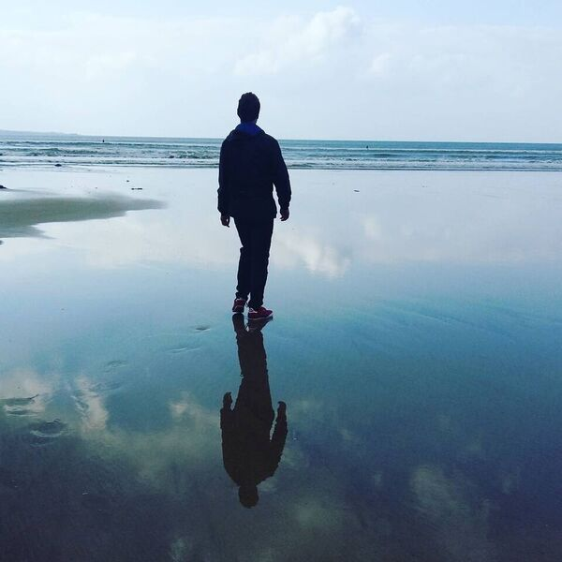
Participants can choose to do either an Expedition or an Exploration. An Expedition is a journey with a purpose and involves a hike/cycle etc. An Exploration is a purpose with a journey. This option might be chosen by a participant is unable to do a 3 day hike/cycle because of an underlying medical condition etc.

Instead of a hike, they are required to spend the 3 days staying away from their usual accommodation doing a project on a specific topic. Participants and PALs will work together to create a plan that meets both the participants’ and Gaisce’s requirements.

Examples of Expeditions | Examples of Explorations
Walk a number of stages of the Wicklow Way following the guide written by J. B. Malone the founder of the Wicklow Way. | Exploring the natural world: glaciation, erosion, geology, coastal studies, river valleys, plant studies, bird studies, animal studies, insect studies etc.
Plan a hike on Achill Island following the footsteps of one of the many artists who sought inspiration for their work on the island. | Exploring historic land use.
Hike on the Burren, considering the impact of tourism on the flora, fauna of the Burren. | Investigating the evolution or extinction of a language.
Hike on the Slieve Bloom Mountains, keeping a detailed account of how as the group followed the Leave No Trace principals. | Exploring human impact on the landscape: visitor pressure in national parks, litter studies, pollution monitoring, surveys of numbers of walkers in remote areas etc.
Hike in the Comeragh Mountains using photography to record the journey. | Personal artistic expression or aesthetic appreciation.
Examples of Expeditions | Examples of Explorations
Identify a Way Marked Way trail and research how many megalithic tombs or markings are along the chosen route, using photography or sketches to record them. | Investigating group dynamics in challenging conditions
Hike the Camino de Santiago and observe the social interaction that takes place between people. | Preparing a wheelchair users guide to Glendalough National Park including the hostel and local hotels.
Cycle/hike part of the 42km Great Western Greenway in Mayo, noting the impact of tourism on the locality in terms of facilities and the economy (additional 8km needs to be added). | Travel to Bull Island - research and record the island’s history and the wildlife observed.
Cycle/hike part of the 46km Waterford Greenway using the trip to record the bridges and viaducts along the route (additional 4km need to be added).

Awards Ceremony
Gaisce invites Silver participants who have completed their award to three regional ceremonies. These generally take place around February and are usually in Dublin, Cork and another location (these are subject to change). Organisations can also choose to organise their own ceremonies; all Silver participants will be invited to the Gaisce ceremonies. If participants cannot attend the Gaisce ceremony, medals, certs and pins will be sent to the PAL to distribute.

‘Time and again we witness the great wealth of talent and innovation that our young citizens have to offer society. I have also seen the determination, self-discipline and strength of mind that is essential to the attainment of a Gaisce Award.‘

President Michael D Higgins

