Bronze Award Record Sheet

For recording activities only. Please retain until Award completion is authorised by Gaisce

Participant’s name: ____________________________________ PAL’s name: ___________________________________

Community Involvement activity:
______________________________________________________________________

Wk | Date | Time | Signature of supervisor
1
2
3
4
5
6
7
8
9
10
11
12
13
Personal Skill activity:
__________________________________________________________________________________

Wk | Date | Time | Signature of Supervisor
1
2
3
4
5
6
7
8
9
10
11
12
13

Physical Recreation activity: _____________________________________________________________________________

Wk | Date | Time | Signature of Supervisor
1
2
3
4
5
6
7
8
9
10
11
12
13

__________________________________________________ activity: for an additional one hour per week for 13 weeks
(participants choose to extend one of their activities)

Wk | Date | Time | Signature of Supervisor
1
2
3
4
5
6
7
8
9
10
11
12
13

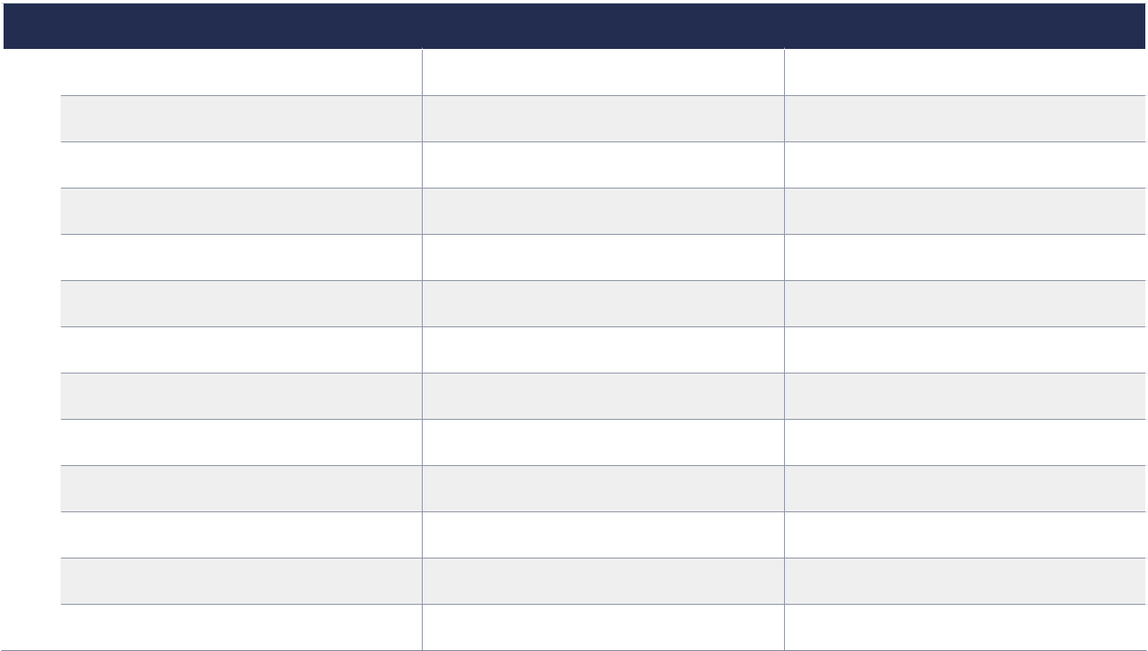
Adventure Journey: 2 days and 1 night

Date From Date To Venue Signature of supervisor

