Bronze Award Requirements

Bronze Award* | Challenge Areas
 | Personal Skill | Community Involvement | Physical Recreation | Personal Skill or  Community Involvement or  Physical Recreation | Adventure Journey
 | 13 weeks | 13 weeks | 13 weeks | + 13 weeks in one area | - days, 1 night
*Participants must be between 15 – 25 years of age when registering. Registration fee of €15 required

Bronze participants complete 13 weeks of activities in the areas of Personal Skill, Community Involvement and Physical Recreation. They then choose one of these areas and do an additional 13 weeks of activities. An Adventure Journey of 2 days and 1 night is also part of the award.

Number of hours per week
Participants do at least one hour per week in each of the 3 challenge areas. They can choose to manage activities in a way that suits them; there is no time limit so they can take more than 26 weeks to complete the award. The 26 weeks do not have to be consecutive (participants can do activities every 2nd week or they can take a break for a few weeks and resume activities when it suits them).

Doing a Bronze Award means committing to 26 weeks of activities; if participants do more than one hour a week in any of the areas, those additional hours cannot be counted – it’s a commitment to 26 weeks of activities rather than a specific number of hours. Gaisce expects participants to do at least one hour a week in each area, but recognise the number of weeks rather than the number of hours.

Activities
Participants will discuss their chosen activities with their PALs before they begin their award. They will work together to ensure that chosen activities are appropriate, they are sufficiently challenging, they demonstrate progression in a specific area and will help them to develop their skills, knowledge and abilities. The activities chosen should be realistic and achievable. Each activity must last for a minimum of 13/26 weeks – participants commit to focusing on one activity in each area and developing their skills in that area. For anybody in full or part time education, activities must be extra-curricular.

Participants should look at www.gaisce.ie to view our Challenge Partners. These are organisations that Gaisce recognises because they offer opportunities to participants that helps them to meet the programme requirements.

Recording Activities
Participants record their activities on a Record Sheet. Activities are signed off by an activity supervisor – for some activities like running or baking, it might not be possible to have a supervisor. In these situations, participants and PALs could agree to recording information by using running apps ( e.g. Map My Run) or participants could create a cook book by recording ingredients, methods and adding in a photo of each meal/cake. These could be shown to the PAL at the end as a way of demonstrating the effort and time committed and also the progression and development of skills. For activities that may not have a supervisor, PALs and participants can decide the best way to record these at their initial meeting.

Record sheets can be found on the Gaisce website.

For Personal Skill activities, participants will:
- Take up a completely new activity or seek to improve their ability in an activity that they are already engaged in that can be pursued for 13/26 weeks with set goals and targets.
- Undertake activities in their own time.
- Show regular commitment, progress, and improvement in their chosen skill.
- Ensure that there is structure to the learning and a method of recording and monitoring it to demonstrate progress.
- There is no requirement to pay for classes.
‘It just shows you what you can do, if you want to.’
Bronze participant

For Community Involvement activities, participants will:
- Undertake a meaningful activity regularly where they are donating their time to a cause/charity/event/project etc. for 13/26 weeks. This means that whilst some activity may take place within school, university or work hours, most of it should occur outside of these scheduled times.
- Show regular commitment (at least one hour per week).
- Engage in activities that benefit others.

For Physical Recreation activities, participants will:
- Either take up a completely new physical activity or seek to improve their ability in an activity that they are already engaged in.
- Choose an activity that requires physical exertion, for 13/26 weeks.
- Show regular commitment, progress, and improvement.
- Undertake activities in their own time.

There are some examples of popular activities on our website - but it’s not an exhaustive list, so there are many more activities that are suitable.

Adventure Journey
A Bronze participant will spend 2 days and 1 night on their Adventure Journey. Most people hike 25km over the 2 days, those that choose to cycle cover 100km over the 2 days. It can take place in Ireland or outside of Ireland at any time of year.
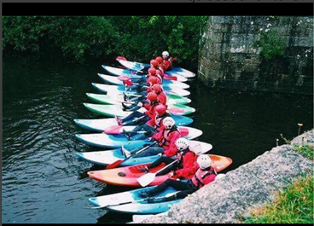
PAL supervision
Bronze participants under 18 years of age, must be accompanied and supervised by their PAL on their Adventure Journey for insurance and Child Protection reasons.
If a participant is over 18, their PAL does not have to supervise the Adventure Journey. However participants will communicate their plans to their PAL before the trip. Health and Safety must also be a consideration and the journey should consist of between 4 and 10 people. Additional people that go on the trip do not need to be Gaisce participants.

Adventure Journey Requirements
- PALs’ Role: Participants must communicate their Adventure Journey plans with their PAL to ensure that they are meeting all of the required elements and their PAL is happy to sign off on the Adventure Journey when completed.
- Planning: The group will prepare and plan the journey themselves and make decisions.
- Journey: At Bronze Award level, looped walks are acceptable.
- Purpose: The journey should have a specific purpose – apart from the distance covered. It might be an artistic purpose (take a series of photographs to record the natural world), historic purpose (compare land use now and how previous generations used it), environmental purpose (examining water levels, water quality etc.), team building purpose (experiencing group dynamics and social interaction, roles within groups etc.).
- Transport: Participants can choose to hike, cycle, canoe or sail – or travel on a horse or camel. With canoeing, sailing or horse riding, the distance covered is less significant than the amount of hours spent on the journey each day. Both parties will discuss this and a decision about what is appropriate in terms of time and distance will depend on factors such as previous experience, terrain, facilities, logistics, weather etc.
- Accommodation: Participants stay in a hostel, camp, or self-contained accommodation.
- Meals: They will cook at least one substantial meal per day (this could be breakfast, lunch or dinner).
- Adventure Journey Policy: Read the Adventure Journey policy available on the Gaisce website.

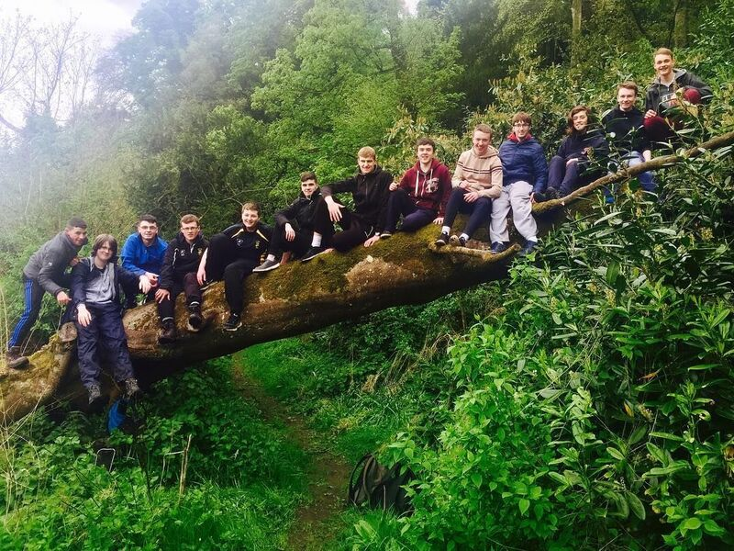
Expedition or Exploration
Participants can do either an Expedition or an Exploration. An Expedition is a journey with a purpose and involves a hike/cycle etc. An Exploration is a purpose with a journey. This option might be chosen by a participant who is unable to do a 2 day hike/cycle because of an underlying medical condition etc. Instead of a hike, they are required to spend the 2 days staying away from their usual accommodation doing a project on a specific topic. Participants and PALs will work together to create a plan that meets both the participants’ and Gaisce’s requirements.

‘It’s a lifetime achievement to challenge yourself.. and [to discover] where your limits are’
Bronze participant

Examples of Expeditions | Examples of Explorations
Walk a number of stages of the Wicklow Way following the guide written by J. B. Malone the founder of the Wicklow Way. | Exploring the natural world: glaciation, erosion, geology, coastal studies, river valleys, plant studies, bird studies, animal studies, insect studies etc.
Plan a hike on Achill Island following the footsteps of one of the many artists who sought inspiration for their work on the island. | Exploring historic land use.
Hike on the Burren, considering the impact of tourism on the flora and fauna of the Burren. | Investigating the evolution or extinction of a language.
Hike on the Slieve Bloom Mountains, keeping a detailed account of how as the group followed the Leave No Trace principles. | Exploring human impact on the landscape: visitor pressure in national parks, litter studies, pollution monitoring, surveys of numbers of walkers in remote areas etc.
Hike in the Comeragh Mountains using photography to record the journey. | Personal artistic expression or aesthetic appreciation.
Identify a Way Marked Way trail and research how many megalithic tombs or markings are along the chosen route, using photography or sketches to record them. | Investigating group dynamics in challenging conditions
Hike the Camino de Santiago and observe the social interaction that takes place between people. | Preparing a wheelchair users guide to Glendalough National Park including the hostel and local hotels.
Cycle/hike part of the 42km Great Western Greenway in Mayo, noting the impact of tourism on the locality in terms of facilities, the economy or the environment. | Travel to Bull Island - research and record the island’s history and the wildlife observed.
Cycle/hike part of the 46km Waterford Greenway using the trip to record the bridges and viaducts along the route. | 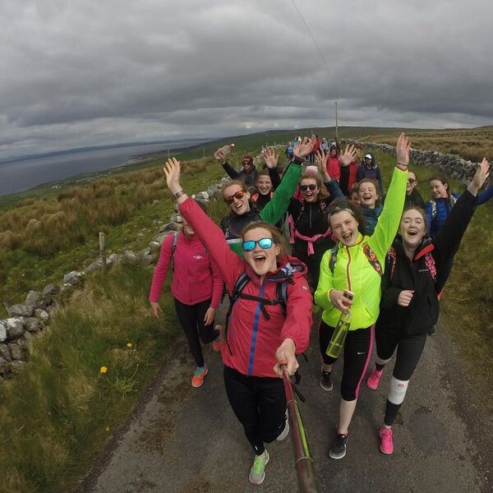
Hike some of Ireland’s ancient Camino pilgrimage routes. Options include Tóchar Phádraig, Co. Mayo (35km), St. Kevin’s Way, Co. Wicklow, St. Finbar’s Pilgrim Path, Co. Cork (35km) or Cnoc na dTobar, Co. Kerry. See www.pilgrimpath.ie

Awards Ceremony
Each organisation that offers the Gaisce programme will organise their own Bronze Award ceremony at local level.

