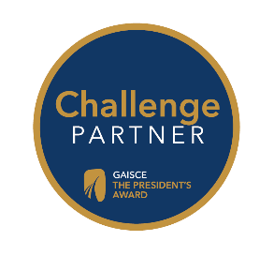
Gaisce’s Challenge Partners
A Gaisce Challenge Partner provides opportunities for participants to meet part of their Gaisce requirements. Below is a list of our current Challenge Partners with a brief explanation of the organisation and how they can support participants to meet Gaisce requirements. Please note that each activity can only be used to meet one of the Gaisce challenge areas i.e. one activity cannot meet both the Personal Skills and the Community Involvement areas.

Our list of Challenge Partners is constantly growing, so check the Gaisce website for up-to-date information (gaisce.ie). Please note, activities do not have to be done in conjunction with Challenge Partners.
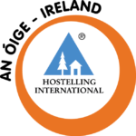

An Óige – Ireland aim to help young people appreciate the countryside, foster an appreciation of Ireland’s cultural and historical heritage and provides safe, affordable accommodation and travel experiences around Ireland.
HOW: An Óige facilitates Gaisce participants to complete their Adventure Journey by offering low cost, accessible hostel accommodation. They will also offer (where available) the services of a Guide (an experienced and Garda vetted volunteer with knowledge of the surrounding trails and walks) to organisations/groups using An Óige hostels for the Bronze Award.
Contact: 01 830 455; programmes@anoige.ie or visit https://anoige.ie/bronze-adventure-journey/
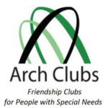
Arch Clubs were established in 1976 to provide a secure, social environment for people with special needs, their siblings and friends to learn, form friendships and above all have fun. At present, there are over 50 community-based social-inclusion-for-all Arch Clubs spread across the country.
HOW: Arch Clubs facilitate Gaisce participants to complete the Community Involvement challenge area by volunteering with a club or becoming an active member of an Arch Club, the Personal Skill area can be achieved through participation in any of the skill based activities in the club and the Physical Recreation area could be met by engaging in sports based activities run by the club.
Contact: 01 2951081 or archclubs@eircom.net
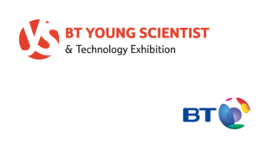
BT Young Scientist and Technology Exhibition is a project based STEM initiative open to all second level students on the island of Ireland. Individuals or groups of up to three can enter a science based project in the competition.
HOW: BT Young Scientist and Technology Exhibition facilitates Gaisce participants to meet the Personal Skill challenge area by planning, researching, preparing and creating a project.
Contact: 1800 924362 or youngscientist@bt.com
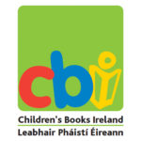
Children’s Books Ireland aims to engage young people in reading and fosters a greater understanding of the importance of books to unlock a passion for literature.
HOW: Children’s Books Ireland facilitates Gaisce participants to meet either the Personal Skill or the Community Involvement challenge areas through involvement in their Shadowing Scheme. The Shadowing Scheme and Children’s Choice Award are tangible ways of making young people’s voices heard and offers Gaisce participants the opportunity to make a difference in the lives of young readers as well as developing their own skills in a specific area of interest.
Contact: 01 8727475 or info@childrensbooksireland.ie
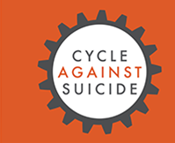
Cycle Against Suicide raises awareness about the issue of suicide, offers reassurance that ‘It’s ok not to feel ok and it’s absolutely ok to ask for help’ and direct people to get help locally and nationally. A two week cycle is organized each year.
HOW: Cycle Against Suicide facilitates Gaisce participants to meet the Community Involvement challenge area by promoting the charity or assisting adult volunteers. Participants can meet the Personal Skill area by getting involved in the Communications (social media, website and promotion), leadership or organisation of events. Participants can also meet the Physical Recreation area by cycling with the aim of taking part in a section of the Cycle Against Suicide cycle. Involvement in the cycle could also meet requirements for an Adventure Journey.
Contact: info@cycleagainstsuicide.com
Don Bosco Care works with some of the most at risk people in Ireland and provide residential care, residential aftercare and outreach aftercare for young people who can’t live at home because of violence, neglect or addiction.
HOW: Don Bosco Care facilitates Gaisce participants to meet their Community Involvement challenge area through volunteering with them in general and through involvement in their Don Bosco Cares TY Challenge.
Contact: 01 833 6009 or info@donboscocare.ie
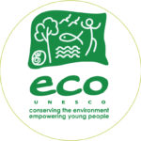
ECO-UNESCO promotes the personal development of young people and raises environmental awareness through practical environmental projects. Their work is based on two simple ideas: “learning by doing” and “thinking globally, acting locally”.
HOW: ECO-UNESCO facilitates Gaisce participants to meet the Community Involvement challenge area by involvement in the YEA Action project or the Eco-Community Development QQI Level 3 module. Participants can also meet the Personal Skill area by taking on a specific role within their ECO-UNESCO team e.g. Communications, environmental audit etc.
Contact: 01 662 5491 or info@ecounesco.ie
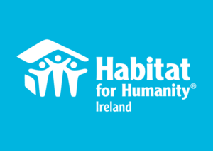
At Habitat for Humanity, our vision is of a world where everyone has a decent place to live. In Ireland, Habitat brings people together from across the community to serve the most vulnerable. It raises funds to support long-term partner programmes in some of our world’s poorest communities.
HOW: Through their schools programme or the global volunteering programme, Habitat for Humanity Ireland facilitates Gaisce participants to meet the Community Involvement challenge area by planning/fundraising/raising awareness and then going on a volunteering trip. The trip could also meet the requirements for the Adventure Journey (Exploration) by living in the local community, building with local families and engaging in cultural activities. At Gold Award level, the schools programme and the Volunteer overseas programme can be used for the Residential Project.
Contact: 015310033 or mary@habitatireland.ie
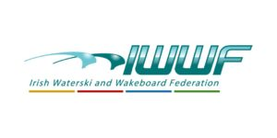
Irish Waterski and Wakeboard Federation (IWWF) is the national governing body for all towed water sports including water skiing, wakeboarding, disabled skiing and barefooting.
HOW: IWWF facilitates Gaisce participants to meet the Physical Recreation challenge area.
Contact: info@irishwwf.ie
CoderDojo’s vision is a world where every young person has the opportunity to learn code and be creative in a safe and social environment.
HOW: Coderjo facilitates Gaisce participants to meet either the Personal Skill challenge area by developing their coding skills through the programme or could meet the Community Involvement area by voluntarily teaching others how to code.
Contact: ross@coderdojo.org or tara@coderdojo.org
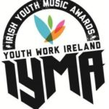
Irish Youth Music Awards (IYMAs) is a flagship programme of Youth Work Ireland. The programme focuses on using music as an educational tool for young people aged from twelve to nineteen years of age and offers them hands on experience learning new skills in the music industry.
HOW: The IYMAs facilitates Gaisce participants to meet the Personal Skills challenge area by involvement in the programme; activities could include: when a song / act is chosen at the Local Live Selection Night, participants of the ‘support team’ volunteer in roles such as social media management or membership of the fundraising team.
Contact: iymas@youthworkireland.ie

Sail Training Ireland is a fun and exciting adventure that has a profound impact on the lives of participants. ‘Trainees’ take part in voyages at sea on tall ships and yachts during which they become part of the working crew
HOW: Sail Training Ireland facilitates young people to meet the Personal Skill challenge area by learning nautical skills. Gaisce participants who volunteer as Youth Mentors could use this to meet the Community Involvement area. The Tall Ships trip could also meet the Adventure Journey or the Residential Project requirements.
Contact: 018711745 or info@sailtrainingireland.com
Young Saint Vincent de Paul is a youth development programme that encourages and supports young people to engage in positive meaningful volunteering activities within their own communities where they have the opportunity to learn about issues of social justice and work towards creating a fairer and more just society for everyone.
HOW: Young Saint Vincent de Paul facilitates Gaisce participants to meet their Gaisce requirements by volunteering for their Community Involvement or developing Personal Skills by taking on elected roles (e.g.President,Secretary,Treasurer etc.).
Contact: 8848233 or becca@svp.ie/youth@svp.ie
SciFest is a series of one-day science fairs for second-level students hosted in schools and at regional level in third level colleges with a national final each November. The project encourages a love of science, technology, engineering and maths through active, collaborative, inquiry-based learning and provides a forum for students to present and display their scientific investigations.
HOW: SciFest facilitates Gaisce participants to meet the Personal Skill challenge area through involvement in the programme via their science based projects. Gaisce participants, particularly college students involved in supporting a regional coordinator to organise SciFest@College, can use these activities to meet the Community Involvement area.
Contact: 086 379 6143 or sheila.porter@scifest.ie
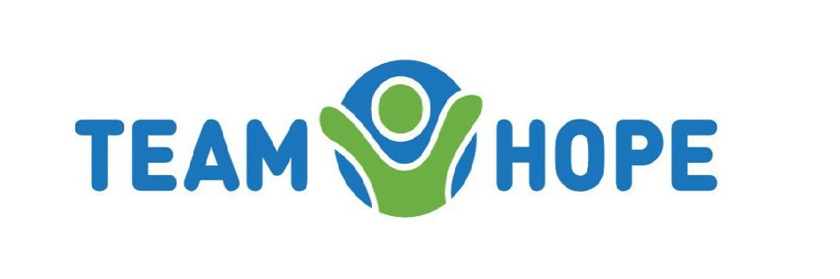
Team Hope is an Irish, international Christian development aid charity, working with children, and through them, into their families and communities in Eastern Europe, former Soviet Union and Africa. Team Hope is best known for their Christmas Shoebox Appeal, but they also help children all year round through a variety of community development projects, an International Sponsorship Programme and International Volunteer Teams.
HOW: Team Hope facilitates Gaisce participants to meet their Community Involvement challenge area through involvement in their 13 week TY programme or by getting involved in the organisation and collection of the shoeboxes. Gaisce particpants may choose to use this activity to meet their Personal Skill requirements as it involves organisational skills, time management, Communications and team work etc. Participants could meet their Residential Project requirements by travelling with their faith-based International Volunteer Team.
Contact: Rachel 01 294 0222 or info@teamhope.ie
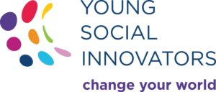
Young Social Innovators (YSI) is a not-for-profit organisation that recognises and celebrates excellence in youth-led innovation and facilitates 12 – 18 year olds to make a positive change in their communities and beyond. YSI programmes promotes social innovation in education, empowers young people to realise their potential and to build their skills and confidence in tackling social issues that face them and their communities.
HOW: YSI facilitates Gaisce participants to meet the Community Involvement challenge area by involvement in any task that a participant does as part of their YSI Action project that enhances either their school or centre or their local, national or international community. YSI team members could meet the Personal Skill area by taking on a specific role within their YSI team (e.g. Communication, organisation, fundraising, budgeting, time management, leadership, photography etc.).
Contact: 01 645 8030 or admin@youngsocialinnovators.ie
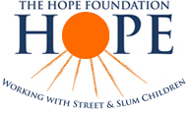
The HOPE Foundation works with street and slum children in Kolkata, India who are some of the most disadvantaged children in the world today. They reach out to those most forgotten; offering protection, healthcare, nutrition, education, rehabilitation and a family for life.
HOW: HOPE facilitates Gaisce participants who volunteer with them to meet the Community involvement challenge area through involvement in their School Immersion Programme, Overseas Volunteer Programme, HOPE Volunteers and their Third Level Partnerships. HOPE volunteers could also meet the Personal Skill area through their fundraising, awareness raising, organisational or mentoring/teaching activities. Travelling to Kolkata and volunteering would meet requirements for the Gold Award Residential Project.
Contact: 021 4292990; 01 8716930 or office@hopefoundation.ie
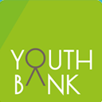
YouthBank is a unique way of involving young people in grant-making within their local community. It is an all-island of Ireland initiative of over 25 grant-making committees run by young people. The funding distributed by these decision-making committees supports projects designed and run by young people that address issues and concerns relevant to them and their community.
HOW: YouthBank facilitates Gaisce participants to meet the Personal Skill challenge area through their involvement in the programme and enhancing skills in leadership, team-work, decision-making, problem-solving, communication, etc. Involvement could also meet the Community Involvement area as they volunteer time and effort into being part of decision-making committees and distribution of funds in their community.
Contact: 086 8101107 or edel@iyf.ie
Cell EXPLORERS is a science education and outreach programme based in the School of Natural Sciences in the National University of Ireland Galway. They work on a unique model where volunteers and student projects combine to allow sustainable outreach. There are 10 teams running science activities in schools on a voluntary basis. Third level students and employees are involved in public engagement in science.
HOW: Cell EXPLORERS facilitates Gaisce participants to meet the Community Involvement challenge area through their volunteering activities with the group. Region: Galway.
Contact: cellexplorers@nuigalway.ie

Deaf Communications Ltd. aims to promote Irish Sign Language (ISL) and publish ISL materials, with particular focus on creating an ISL dictionary. They create educational material and resources for children, students and Deaf children. They have created a teaching module for second level students that introduces young people to ISL.
HOW: Deaf Communications Ltd. facilitates Gaisce participants to meet the Personal Skill challenge area for a Bronze Award by completing their 13 weeks Irish Sign Language module. Region: Dublin, possibly surrounding counties.
Contact: 086 2573366 or pauline.mcmahon100@gmail.com
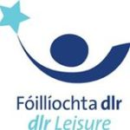
DLR Leisure Meadowbrook is located in the Dundrum/Ballinteer area. DLR Leisure currently operates four Leisure Centres. Our mission statement is “to promote leisure facilities and sporting experiences that are accessible, inclusive and customer focused.” We strive to deliver high standards, provided by qualified staff, to enhance and support a healthy lifestyle. We provide gyms, swimming pools, fitness studios and all weather pitches.
HOW: Through our Teen Gym programme, Gaisce participants can fulfil their Physical Award section.
Contact: 012995610 or ccull@dlrleisure.ie
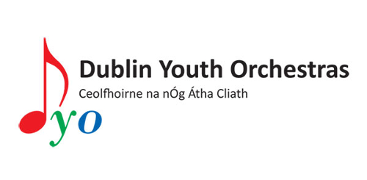
Dublin Youth Orchestra provides young musicians between the ages of nine and nineteen years, with the opportunity to play and perform orchestral and chamber music whilst encouraging and fostering a love for and appreciation for ensemble playing.
HOW: Dublin Youth Orchestras facilitates Gaisce participants to meet the Personal Skill challenge area through their musical activities in the orchestra. They can also engage in voluntary activities that support DYO in the production of community based concerts by mentoring younger members of the orchestra, event planning, producing promotional material and involvement in community concerts etc. Region: Dublin, Leinster.
Contact: 0868328127 or junior@dyo.ie
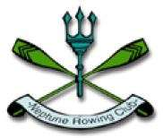
Neptune Rowing Club is one of the largest boat clubs in Ireland. The club is dedicated to promoting the sport of rowing. It’s one of the largest clubs in Ireland and is one of only two clubs in Dublin which is not affiliated to an institution.
HOW: Neptune Rowing Club facilitates Gaisce participants to meet the Physical Recreation challenge area for the Bronze Award by providing a series of rowing lessons for young people through their Junior Rowing programme. Participants may undertake group or individual lessons or may choose to row independently. Gaisce participants could also complete either the Community Involvement or Personal Skill aspect of their award if they volunteer with the club as a volunteer coach. Region: Dublin 7, 8,15.
Contact: www.neptunerowingclub.com
The SWICN Clubhouse in Dublin 8 works with 10 – 18 year olds and teaches them how to use professional software for design, exploration and experimentation. Members can explore professional and academic opportunities and learn from others in their chosen field.
HOW: The SWICN Clubhouse facilitates Gaisce participants to meet their Personal Skill challenge area through engagement with Clubhouse activities and may meet the Community Involvement area by volunteering time to sharing information with attendees. Region: Dublin 8.
Contact: 01 4536674 or theclubhouse@swicn.ie
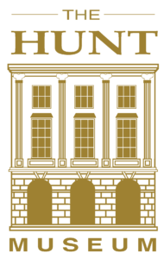
The Hunt Museum preserves and exhibits the original artefacts gathered by John and Gertrude Hunt. The museum displays its own collections, visiting exhibitions with the overall aim of maximising their cultural and educational potential for the people of Limerick and Ireland.
HOW: The Hunt Museum facilitates Gaisce participants to meet the Personal Skill and the Community Involvement challenge areas by volunteering in the museum in a variety of roles. Region: Limerick.
Contact: 061 312 833 or info@huntmuseum.com
Vita is an international non-governmental organisation based in Dublin and working within East Africa in Ethiopia and Eritrea. They work within rural communities mostly female headed households tackling hunger and climate change. Some of their programmes include the repair of water pumps, provision of fuel efficient stoves and training in climate-smart agriculture. All of these reduce the hours spent by people, mostly women and children from collecting wood and water meaning they have more time to spend attending an education.
HOW: Vita facilitates Gold Gaisce participants to travel to Ethiopia, take part in the 10km Great Ethiopian Run held in November and visit Vita programmes. This trip is organised by Vita which Gaisce participants fundraise and raise awareness about Vita throughout the year and then go on the seven day trip.
Contact: 01 873 4303 or communications@vita.ie
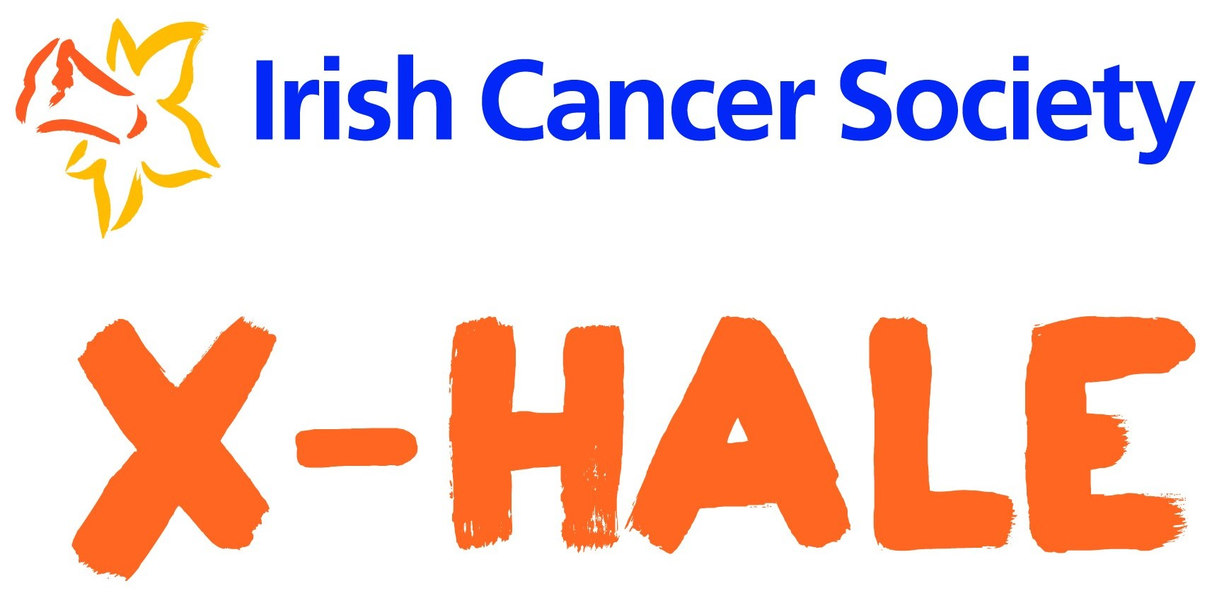
X-HALE is an initiative set up by the Irish Cancer Society which partners with youth organisations and young people to work towards a tobacco free generation. According to research, about 8% of young people aged 10-17 in Ireland smoke.
HOW: The X-HALE 2018 Short Film Competition is an exciting opportunity for youth groups to spread the word about the impact of smoking by creating and promoting a youth-led short-film. Every year, the Irish Cancer Society support youth groups from all over Ireland in making a short film to encourage young people to be smoke free. This Partnership recognises that participation in X-HALE can be used for Community involvement or Personal skill for the Bronze Gaisce award.
Contact: schadwick@irishcancer.ie or 01 231 6624
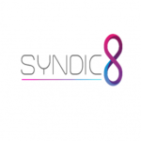
SYNDIC8 is a programme that focuses on engaging the youth of today in STEM (Science, Technology, Engineering and Maths).
HOW: SYNDIC8 host a global competition encouraging students to develop and learn practical skills in sectors such as aerospace, automotive, robotics and programming alongside boosting their entrepreneurial skills under our year-long challenge. This programme involves the students learning key skills such as being part of a team, research and design skills, manufacture, presentation skills creating a portfolio as well as evaluating and modifying the car or drone they have designed. This programme is designed to fit into the school calendar year as a module to be completed each week. There are three areas: F1 in schools, RC Rally, Drone Racing. Taking Part in any of these areas can meet the Personal Skill requirements of the Bronze or Silver Award providing it meets the relevant time requirements.
Contact: info@syndic8.org or 01 565 4834
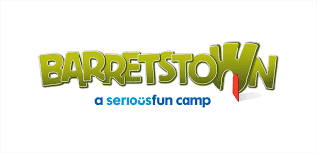
Barretstown offers free, specially designed camps and programmes for children and their families living with a serious illness – supported behind the scenes by 24 hours on site medical and nursing care. Barretstown is supported by donations and the fundraising efforts of corporate supporters, individuals and community groups. Barretstown is recognised as a centre of excellence in childhood cancer care and other serious illnesses. Children are referred to Barretstown based on their medical needs.
HOW: Volunteering with Barretstown will meet the requirements for a Gold participants Residential project. Volunteering at Barretstown is a truly unforgettable experience – fun activities, lots of laughs and the knowledge that you are directly helping seriously ill kids and their families turn their lives around. As a volunteer you perform a key role in supporting and encouraging each child to take part in all aspects of camp, while making sure they’re safe and supervised at all times. Most importantly you’ll help them have fun! You will be assigned to work with a family and/or activity group of children depending on the camp you attend. You will encourage and support the children and parents to partake in all activities and to act as a Cara “friend”. You must commit to the full camp session. Barretstown is a residential camp – Food and accommodation is provided. Training is provided for all camps.
Contact: Andrea Smyth at andrea.smyth@barretstown.org
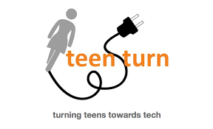
Teen Turn & The Digital Hub have created an after school programme for girls between the ages of 13-18 to work in teams to build mobile apps, develop social enterprise plans and engage in scientific research. Participants are required to create projects that revolve around the themes of peace, poverty, environment, education, equality, and health. This is supported by mentors and guided by SciFest and BT Young Scientist requirements as well as the Technovation Challenge 13-week curriculum. Participants compete for the opportunity to pitch their projects at Google’s Mountain View headquarters in California with (flights, accommodation and meals) paid for. https://teen-turn.com/current-programs/afterschool/
HOW: Gaisce participants who get involved with this great programme can use the experience toward their community or personal skill section of their Award.
Contact: 0872211086 or programme@teen-turn.com
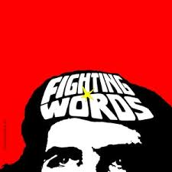
Fighting Words provides free tutoring and mentoring in creative writing and related arts to as many children, young adults and adults with special needs as we can reach. Our programmes and workshops are delivered mainly by volunteer writing tutors.
HOW: Fighting Words runs a Write Club programme for young people aged between 13 and 18 to come to Fighting Words and work on their own independent writing projects at our locations in Dublin, Dún Laoghaire and Bray. Gaisce participants can get involved with Fighting Words and use this great experience toward their Personal Skill section of their Award.
Contact: 0872746621 or sara@fightingwords.ie
Dublin International Film Festival (DIFF) curates and presents the best in emerging International and Irish film and moving image culture for a wide audience through its flagship annual festival, along with a range of year-round events. DIFF aims to offer memorable experiences through audience interaction and engagement with filmmakers, actors and industry professionals, along with informed debate about the future of film as an art form.
HOW: DIFF offers Gaisce participants the opportunity to meet their Personal Skill requirements by taking part in DIFF’s new Screen8 programme for 14-to-16-year old teenagers living in Dublin 8 and its surroundings. Screen8 will give budding young filmmakers hands-on experience of making movies. They will work collaboratively on the production of a short film under the supervision of an Irish filmmaker and the film will be shown at the Dublin International Film Festival in February 2019. The free pilot programme will give 15 young people an opportunity to be creative and develop film-making skills and talents over six months. Classes will be held once a week at The Digital Hub and will start on Saturday, 15th September 2018.
Contact: projects@diff.ie or 01 662 4260
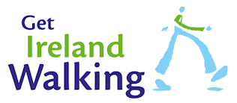
Get Ireland Walking is a national initiative that aims to maximise the number of people participating in walking for health, well-being and fitness throughout Ireland. They aim to promote the benefits of walking and support walking groups and independent walkers.
HOW: Get Ireland Walking facilitates Gaisce participants to meet their Physical Recreation challenge area by supporting them to walk individually and by assisting them to set up walking groups.
Contact: info@getirelandwalking.ie or 01 625 1109
National Gallery of Ireland houses the national collection of Irish and European art. The collection has around 14,000 artworks, including about 2,500 oil paintings 5,000 drawings, 5,000 prints and some sculpture and furniture and other works of art.
HOW: National Gallery of Ireland facilitate Gaisce participants to meet the Personal Skill challenge are by involvement in their ‘Programmes for Young People (16-25)’ and their ‘Teachers and Schools Programmes.’
Contact: codonnell@ngi.ie or 01 663 3579
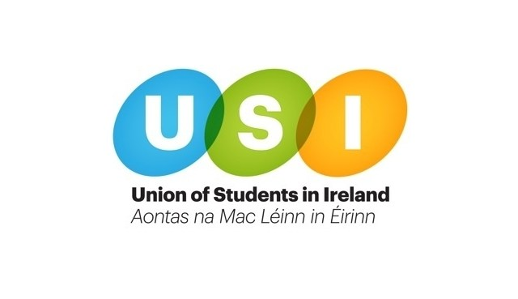
Union of Students in Ireland (USI) is the national representative body for the 374,000 students in third level education on the Island of Ireland.
HOW: USI facilitates Gaisce participants in college to meet either the Personal Skill or the Community Involvement challenge areas by getting involved in USI related activities in college or by volunteering with their college’s USI team and taking on a voluntary role (e.g. Communications, Marketing etc.).
Contact: south@usi.ie
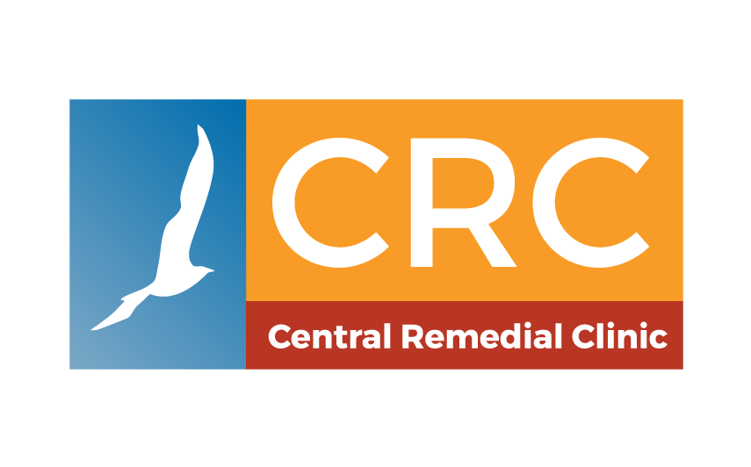
CRC Central Remedial Clinic is committed to working together to make a positive difference to the lives of people with disabilities, their families, and carers. The mission of the CRC is that people with disabilities achieve their potential and live full lives as equal and valued citizens.
HOW: The CRC facilitates Gaisce participants to meet the Community Involvement challenge area through their volunteering activities:
- Swimming – supporting adults or children in the water during swimming classes.
- Dining Room – serving lunches to children and adults with disabilities and maintaining a clean environment.
- Summer project – during the month of July, CRC look for volunteers to support children from 7 to 18 years old during indoor and outdoor activities and outings.
- Fundraising and other activities.
Contact: Volunteer with CRC or 01 854 2200
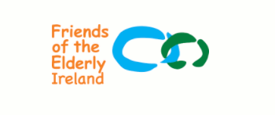
Friends of the Elderly was established in 1980 to bring friendship and companionship to older people living alone or who feel lonely. They take a practical approach to dealing with loneliness and social isolation, alleviating its effects by providing social engagement programmes such as Home Visitation, Friendly Call Service, Social Club and organising Day Trips or Social Events.
HOW: Friends of the Elderly facilitates Gaisce participants to meet their Community Involvement or Personal Skill challenge areas by volunteering with members of the elderly community or by supporting the organisation with promotional/fundraising campaigns.
Contact: info@friendsoftheelderly.ie or 01 873 1855
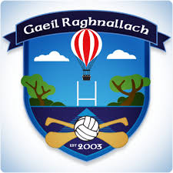
Ranelagh Gaels was formed in Dublin 6 in 2003 and has grown steadily into a permanent fixture in the area. Ranelagh Gaels play their home matches in Bushy Park, Terenure.
HOW: Ranelagh Gaels facilitates Gaisce participants to meet their Physical Recreation challenge area by playing Gaelic football with the club. Gaisce participants can also can also meet their Community Involvement or Personal Skill part of their award if they take on the role of a volunteer mentor/coach in the club.
Contact: leeirenedillon@gmail.com
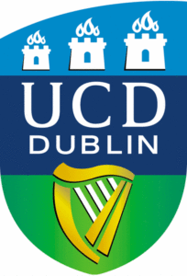
UCD aims to improve policies addressing childhood obesity, by having ordinary citizens (you the students) collect data on their dietary environments via a smartphone app, combined with various online data tools already present on smartphones (maps, registries and geographic information systems). Additionally, we aim to capture the attitudes towards government policy to tax foods/drinks that are considered “unhealthy”, through an attitudinal survey distributed by the Gaisce Citizen Science participants. https://bigoprogram.eu/
HOW: Gaisce participants can fulfil their Personal Skill and Community Engagement award section.
Contact: 0877827705 or james.oconnor@insight-centre.org
The Irish Film Institute is Ireland’s national cultural institution for film. It provides audiences throughout Ireland with access to the finest independent, Irish and international cinema; it preserves and promotes Ireland’s moving image heritage through the IFI Irish Film Archive, and provides opportunities for audiences of all ages and backgrounds to learn and critically engage with film. http://www.ifi.ie
HOW: Developing their film literacy through the challenge area of ‘Personal Skill’ section.
Contact: 016795744 or rfallon@irishfilm.ie
Padel Foundation represent Padel in Ireland. A new sport introduced in 2011. Please see website
HOW: Gaisce participants can use Padel to fulfil their physical recreation section.
Contact: 0871642352 or naominicholl@padelfederation.ie
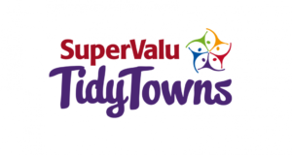
Tidy Towns volunteers meet twice weekly from April to October and weekly during the winter to maintain the environment of towns and keep them litter free as possible and engage in projects which enhance the town being mindful of national strategies e.g. The All-Ireland pollinator plan and biodiversity strategy.
HOW: Community Involvement and Personal Skill and to an extent physical recreation as the work is all outdoors.
Contact: 0851582328 or info@brownesjewellers.ie
Ski Centre provide ski and snowboarding lessons to adults and children. You can visit their website here.
HOW: Gaisce participants can use Ski Centre to full their physical recreation section.
Contact: 0876364815 or carolkennedy@skicentre.ie
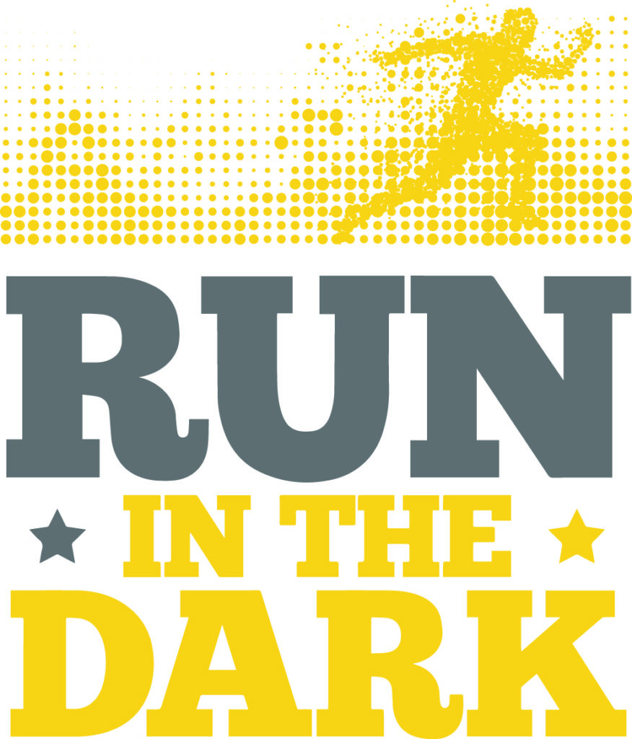
Run in the Dark aims to inspire people to build resilience and collaborate with others so that, together, they achieve more than they thought possible. For some that means gathering a group of friends or colleagues to train hard and get fit with a 5k or 10k run. For others, it means pushing themselves outside their comfort zone and trying a new activity. For Gaisce participants, it means training on a regular basis to build up fitness and feel healthier, no matter what point where they’re starting from. http://www.runinthedark.org
HOW: Run in the Dark facilitates Gaisce participants to complete the Physical Recreation challenge by providing a specialised 13 week training programme, which will enable participants to improve their fitness levels from basic level to being fit enough to run 10k, or to assist participants who already run to make gains in their training. Gaisce participants will have the option to sign up to take part in Run in the Dark in 13 locations around Ireland on Wednesday 13th November 2019, giving them a goal to work towards, and to feel part of a community of 16,000 around the country taking part to run 5k or 10k. Run in the Dark will also facilitate participants to combine this challenge with the Personal Skill challenge by supporting them to set up and managing a Run in the Dark in their school or local area. Participants will learn how to organise and manage an event, manage volunteers, and a run social media campaign.
Contact: 0851215045 or gaisce@runinthedark.org
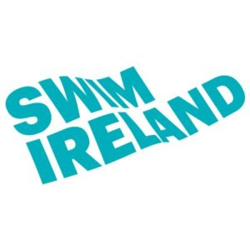
Swim Ireland is the National Governing Body for swimming and associated aquatics on the island of Ireland. Our role is to encourage participation, develop excellence and regulate the competitive element of our sport. We provide support and education at all levels of swimming, whether it be to beginners dipping their toes in the water for the first time, or performance athletes with Olympic ambitions. We also provide accredited education throughout the leisure industry to swim teachers and coaches. An overview of our activity can be viewed on our website.
HOW: We can facilitate 3 of the 4 challenge areas: Community Involvement; Personal Skill and Physical Recreation.
Contact: 0868560672 or katehills@swimireland.ie
STAND celebrates the power of Irish third level students to change the world. With us, you can share your ideas about standing up for justice and equality, learn more about global issues, and find out what you – as an individual and by coming together – can do to take positive action. Stand was set up in 2014 in response to the desire among students and young people in Ireland to learn more about global issues and take action. Our participants come from a range of backgrounds, but all have one thing in common: the desire to bring about positive change in the world.
HOW: Community Involvement: STAND participants can volunteer to run STAND Climate Change Festivals in NUIG, UCD, UCC, TCD, DCU. NUIM & TU. They can all volunteer to write articles on global issues for http://www.stand.ie/news. Finally, there is an opportunity to help organise a STAND Global Issues Course on campus.
Contact: 016621400 or mary@stand.ie
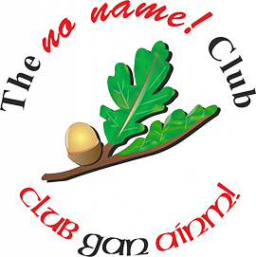
No Name! Clubs are run by, and for young people aged 15-18 years, and enables young members to organise and enjoy positive alternatives to alcohol and drug-centred activities. It increases awareness of the effects of alcohol and drugs, to help young people make informed choices when they are older.
HOW: Participants can use No Name Club to fulfil their Community Involvement Award section.
Contact: 0596400299 or adoyle@nonameclub.ie
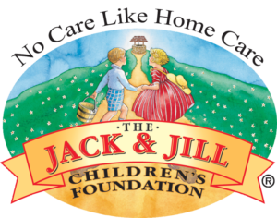
The Jack & Jill Children’s Foundation is a registered Charity that provides home nursing care to babies and children up to the age of 5 with severe to profound neurodevelopmental delay. The charity also provides end-of-life care to children going home to die regardless of their named or unnamed medical condition. it is the only charity that provides this national service, operating 365 days a year, with no waiting list or means testing. The charity has supported almost 2,500 families since 1997 and currently has 358 families under it’s wing from all over Ireland.
HOW: Participants can use the Jack and Children’s Foundation to fulfil their Community Involvement Award section.
Contact: 045894538 or tina@jackandjill.ie
See gaisce.ie for a full list of all our Challenge Partners.

